***Saddle point of a matrix:***

// Saddle point of a matrix

#include <stdio.h>

int main()

{

int n, a[10][10], i, j=0, min, max;

int sad[10], count=0, flag=0, pos=0;

printf("Enter size of matrix: ");

scanf("%d",&n);

for (int r = 0; r < n; r++) {

for (int s = 0; s < n; s++) {

printf("Enter a[%d][%d]: ",r,s);

scanf("%d",&a[r][s]);

}

}

for (i = 0; i < n; i++)

{

min = a[i][0];

for (j = 0; j < n; j++) {

if (min > a[i][j]) {

min = a[i][j];

pos = j;

}

}

max = min;

for (int k = 0; k < n; k++) {

if (max < a[k][pos]) {

max = a[k][pos];

}

}

if (min == max) {

sad[count]=min;

count++;

flag = 1;

}

}

if (flag==1) {

for (int r = 0; r < count; r++) {

printf("The saddle point number is %d, ",sad[r]);

}

}

else {printf("No saddle point\n");}

return 0;

}

Output:

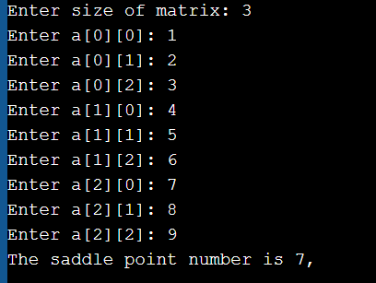

***Determinant of 2x2 matrix***

#include <stdio.h>

int determinant(int a[2][2]){

int det = (a[0][0]*a[1][1])-(a[0][1]*a[1][0]);

printf("Determinant = %d",det);

}

int main(){

int a[2][2], i, j;

printf("Enter elements of 2x2 matrix: \n");

for(int i=0; i < 2; i++){

for(int j=0; j < 2; j++){

scanf("%d",&a[i][j]);

}

}

determinant(a);

}

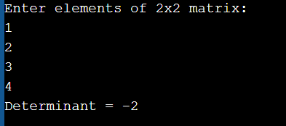

***Inverse of matrix:***

#include<stdio.h>

int main(){

int mat[3][3], i, j, n=3;

float determinant = 0;

printf("Enter elements of 3x3 matrix: \n");

for (int r = 0; r < n; r++) {

for (int s = 0; s < n; s++) {

printf("Enter mat[%d][%d]: ",r,s);

scanf("%d",&mat[r][s]);

}

}

for(i = 0; i < 3; i++)

determinant = determinant + (mat[0][i] * (mat[1][(i+1)%3] * mat[2][(i+2)%3] - mat[1][(i+2)%3] * mat[2][(i+1)%3]));

printf("\n\ndeterminant: %f\n", determinant);

printf("\nInverse of matrix is: \n");

for(i = 0; i < 3; i++){

for(j = 0; j < 3; j++)

printf("%.2f\t",((mat[(j+1)%3][(i+1)%3] * mat[(j+2)%3][(i+2)%3]) - (mat[(j+1)%3][(i+2)%3] * mat[(j+2)%3][(i+1)%3]))/ determinant);

printf("\n");

}

return 0;

}

